**SMART AI CAR 2.5**

**First To Do!**

**Please create these layers in order;**

**Vehicle, and Obstacles.**

**You can add layers from Edit 🡪 Project Settings 🡪 Tags and Layers 🡪 Layers.**

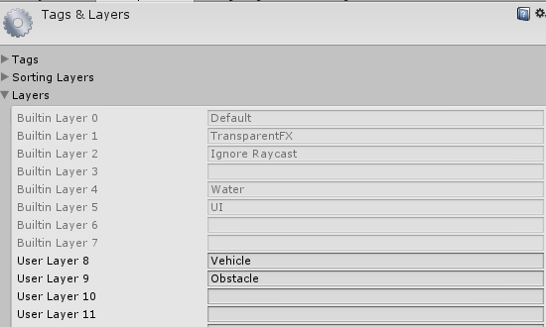

**!!!IMPORTANT!!!**

**Your main gameobject scale must be 1, 1, 1. Otherwise, wheelcolliders will be placed at wrong positions. Be careful about your wheel transforms and colliders x, y, z coords. Z should be facing at forward, X should be right, and Y should be up. Otherwise, transforms and colliders will not act as should be. If your model coords are at wrong direction, just create an empty game object at center of the wheel, set the coords as just like i said, and parent wheel gameobject to that empty new gameobject. But if you want to do more professional and clean work, just edit pivot positions in 3ds max or any other design software. And be sure that all of your wheel colliders scale is set to 1, 1, 1.**

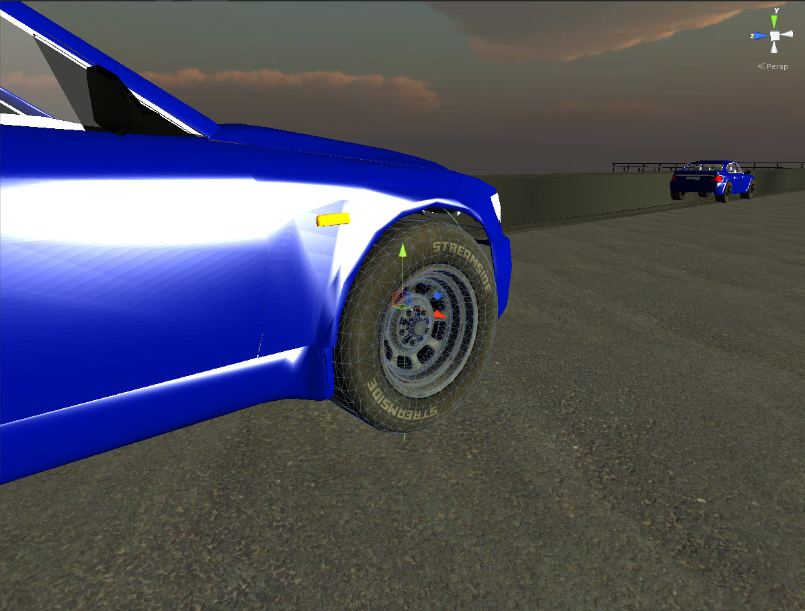

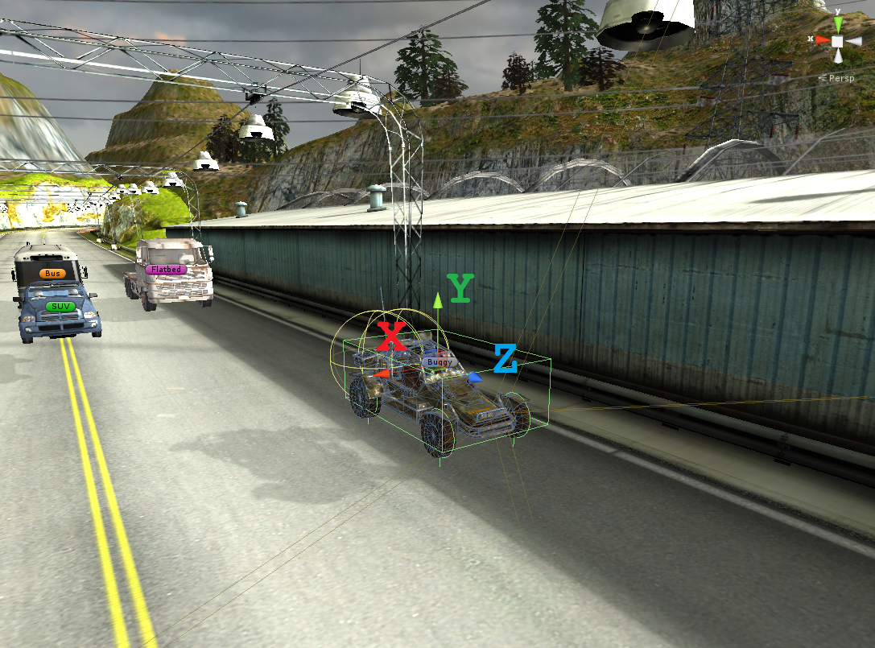

**How to Setup A Scene With AI Cars**

**This is the main Smart AI Car script attached to AI vehicle;**

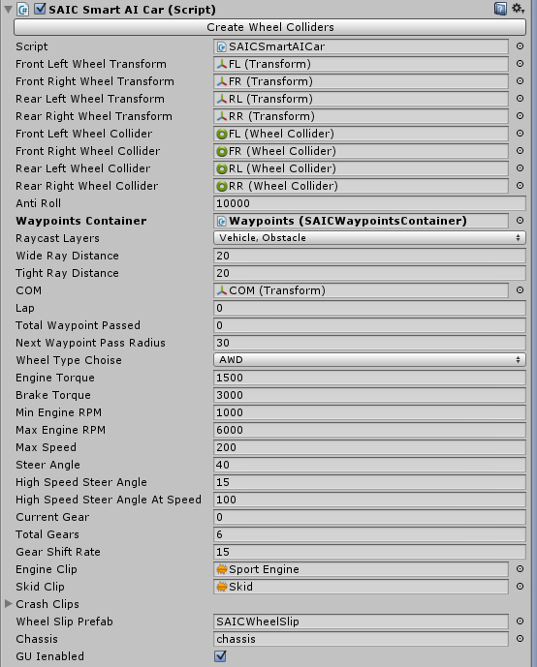

**Creating Path**

**Create empty gameobject and rename it to “Waypoint Container” or something like this. Add “SAICWaypoinsContrainer” script. This gameobject would be your main container for waypoints.**

**Create empty gameobjects and create your path with them. Name your waypoints just like "WP1", "WP2"... Select all of your waypoints in order on Inspector Panel under "Waypoints" section.**

**Parent all waypoints to your waypoint container, and select them inside script.**

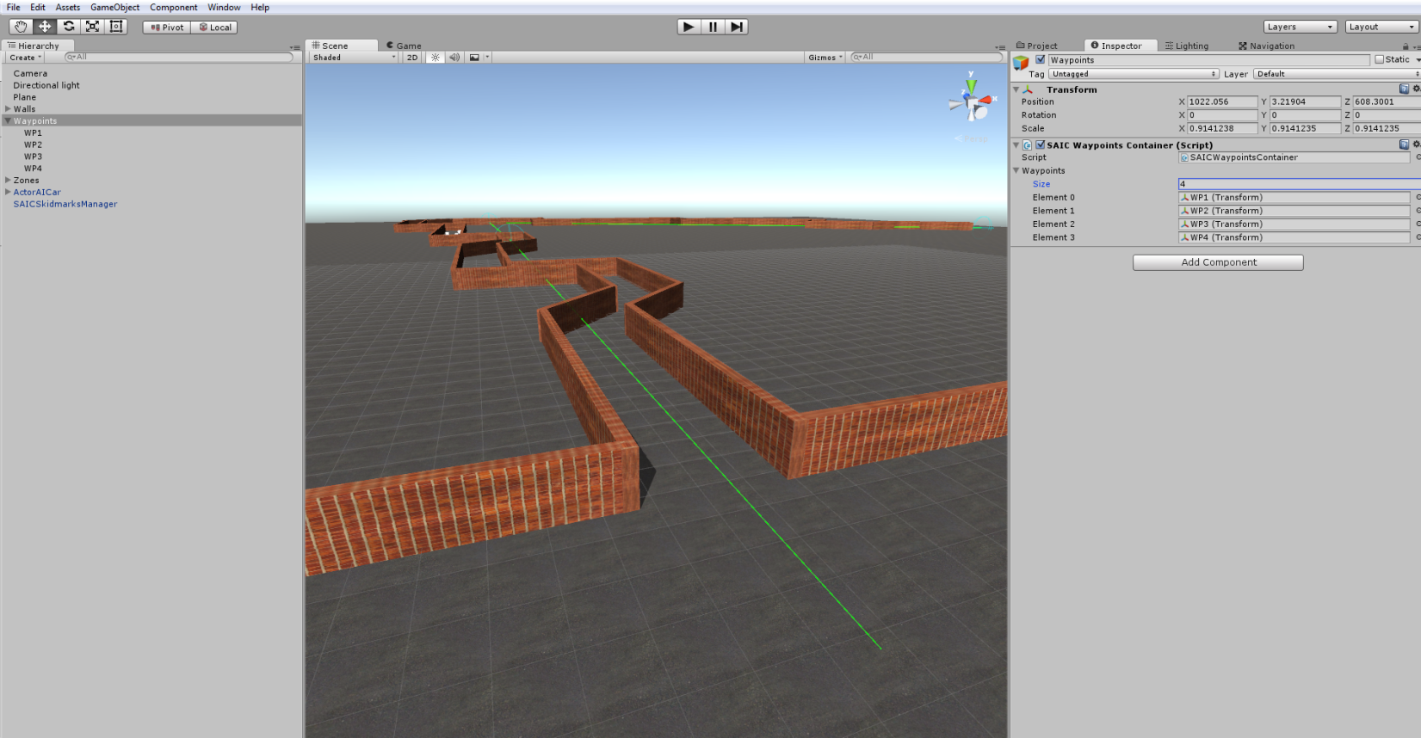

**Then you must bake your navigation mesh. Window 🡪 Navigation. Bake your scene with default settings. Make sure all your obstacles (except movable objects ) must be static objects.**

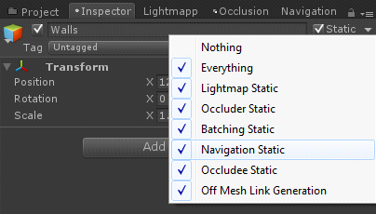

**And you must get a result like this;**

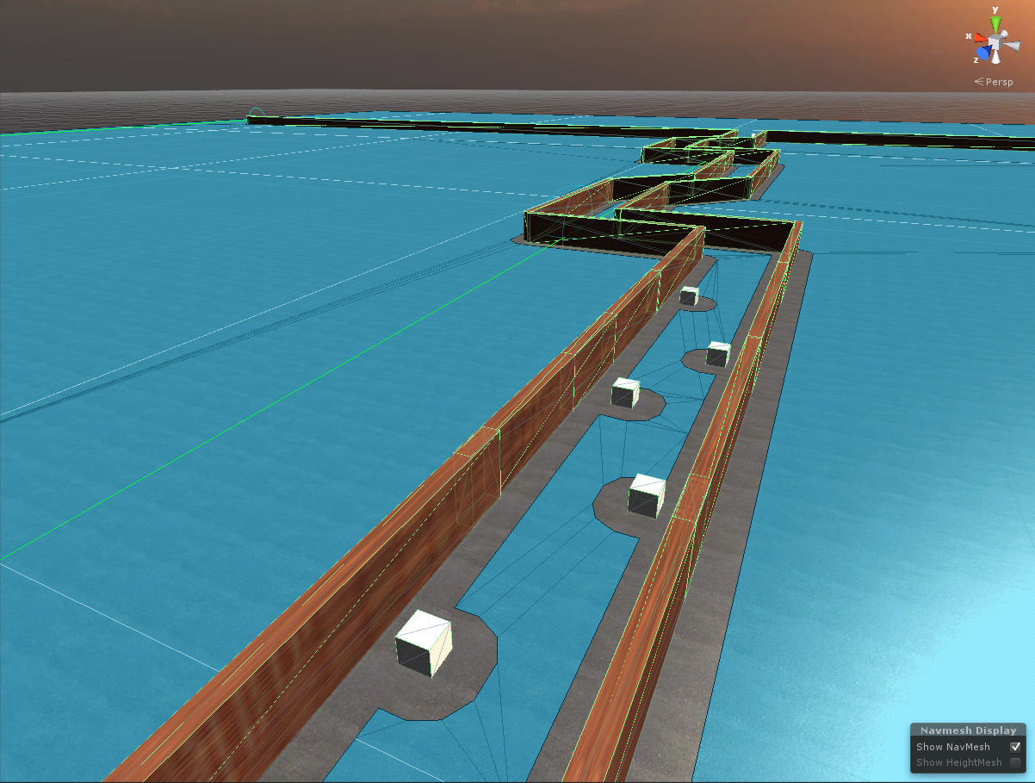

**AI Vehicle Setup**

**Add “SAICSmartAICar” script to root of your car. If you are getting trouble while creating a car, you can watch my tutorials on Youtube, it’s pretty easy. Attach your proper wheel colliders and wheel transforms to the script. As i said, be careful about your wheel transforms and colliders x, y, z coords. Z should be facing at forward, X should be right, and Y should be up. Select all of your wheel transforms in script, and click “Create Wheel Colliders”. Check your wheel colliders size and radius. Should match to corresponding wheel size. All other settings are clearly understandable i think. Set your engine torque, brake torque, maximum minimum bla bla bla...**

**AI Brake Zones**

**You need to create a tag named “BrakeZone”, and trigger for making a break zone. There is a ready to use BrakeZone prefab under Prefabs folder. Simply drag&drop to your scene. Each BrakeZone has “SAICBrakeZone” script. You can set target speed for each individual brake zones.**

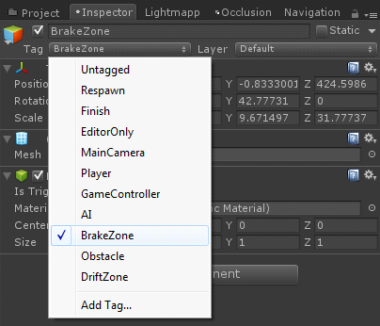

**If you have any questions about my assets, please contact me on bonecrackergames@gmail.com**